% Driver for Q2
close all
clear all
clc
format long
a = 0;
b = 10;
h = 0.1;
n = (b-a)/h;
f1_0 = 0;
f2_0 = 0;
B = 1;
tolerance = 10^(-6);
xf30(1) = 0;
xf30(2) = 2;
[x,f2] = RK4('blasius',a,b,h,f1_0,f2_0,xf30(1));
yf210(1) = f2(n+1);
[x,f2] = RK4('blasius',a,b,h,f1_0,f2_0,xf30(2));
yf210(2) = f2(n+1);
error = abs(yf210(2) - B);
i = 3;
while(error>tolerance)
xf30(i) = xf30(i-1) + (1-yf210(i-1))*(xf30(i-1)-xf30(i-2))/(yf210(i-1)-yf210(i-2));
[x,f2]=RK4('blasius',a,b,h,f1_0,f2_0,xf30(i));
yf210(i) = f2(n+1);
error = abs(yf210(i)-B);
i = i+1;
end
fprintf('Error:\n')
disp(error)
fpp_0 = xf30(i-1);
fprintf('fpp_0: \n')
disp(fpp_0)
plot(f2,x)
xlabel('u/U')
ylabel('eta')
axis padded
grid on
Error:
3.604962106606990e-09
fpp_0:
0.332057347406128
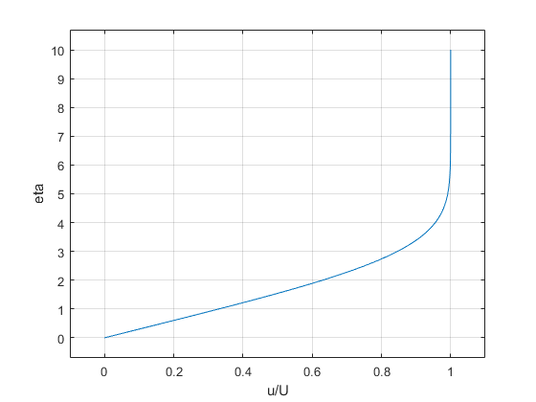
Published with MATLAB® R2021a

